**HTML and CSS Validation screenshots** <https://piboard.jordanwentland.com>

**HTML Validation**

* **Index.html**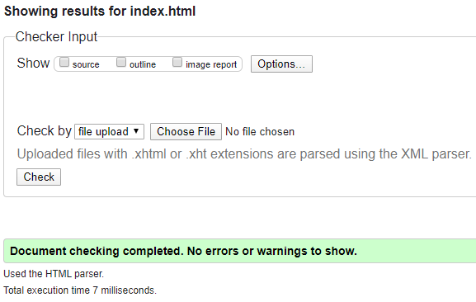
* **Gettingstarted.html**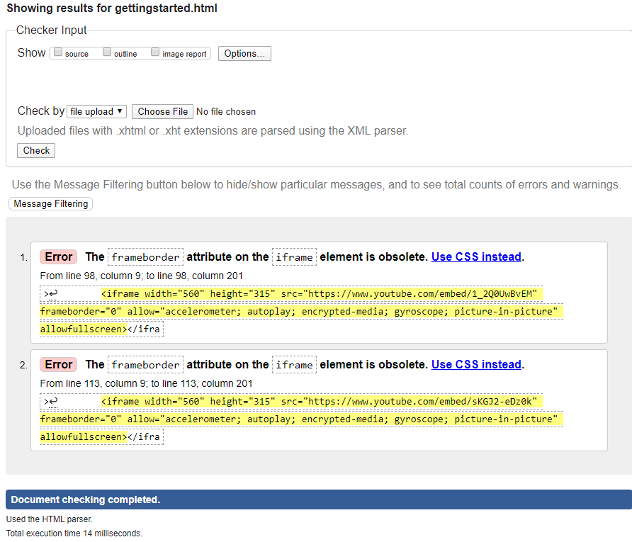
* **webserver.html**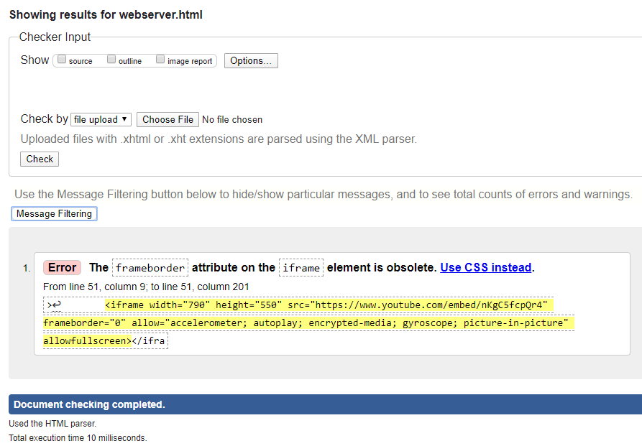
* **minecraft.html**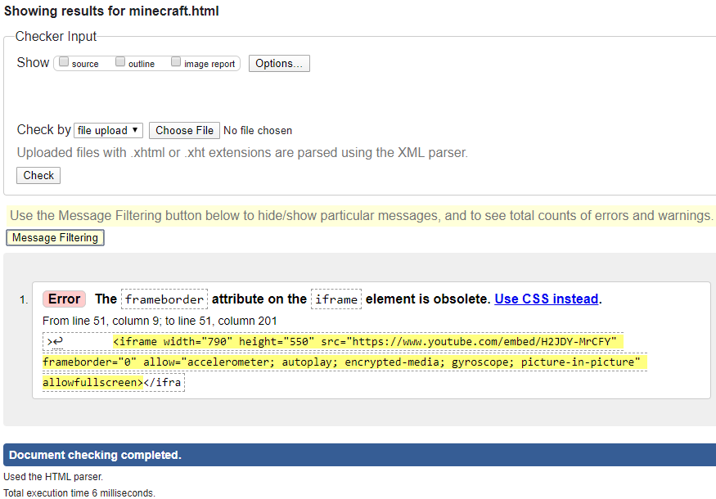
* **docker.html**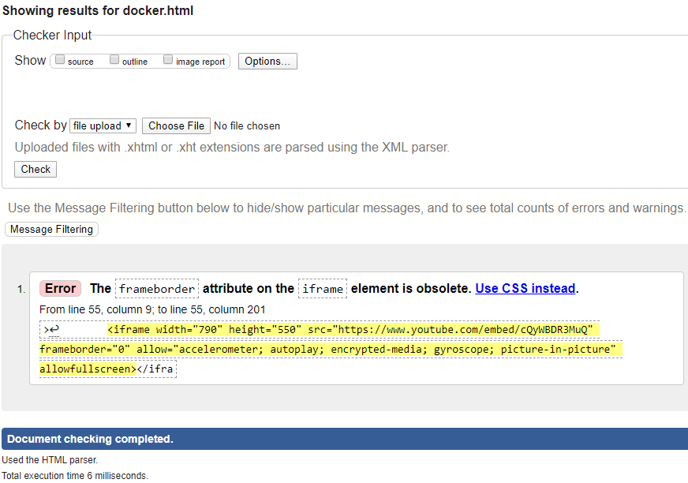
* **contact.html**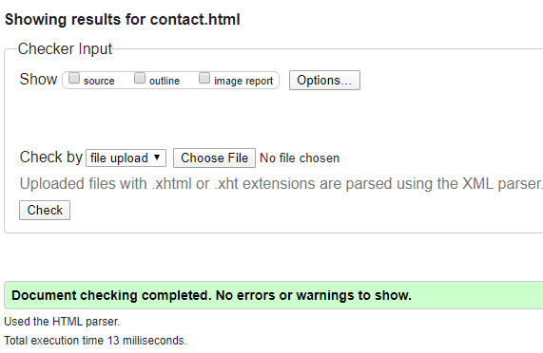

**CSS Validation**

* **GPST.css**